MEDIA CONTACT:
Tim Miller
Guardian Home Health, LLC.
(913) 515-6249
tim.miller@guardianks.com
Norton, Kansas – September 28, 2018

RHONDA REUSINK JOINS GUARDIAN!
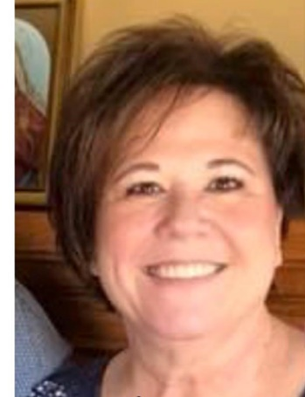
We are thrilled to announce the addition of Rhonda Reusink to our growing team! Rhonda comes to Guardian with a bachelor’s degree and Master’s in guidance and counseling with an emphasis on drug and alcohol addiction. She has also been an area teacher of grades K-8 for ten years in the Northern Valley, KS school district along with many years of experience in the healthcare field. Rhonda has a unique perspective of business as she has also been licensed as an insurance agent. She has held the position of Program Manager at one of Valley Hope’s in-patient facilities where she was responsible for all staff, patients and the physical property. Most recently, Rhonda served as Valley Hope’s Centralized Utilization Review department supervisor in the Norton, KS leading a team of employees who were responsible for all the insurance utilizations in seven mid-western states for the addiction treatment provider.
Rhonda’s role will evolve as the company grows but for the time being, like many of us at Guardian, she is staying busy with quite a few administrative duties associated with the launching of new services to include skilled nursing and the start of the Home Care business whose sole focus will be Medicare clients. Rhonda brings the ability to problem solve and has a real gift for communicating with people.
Rhonda and her husband Doug have three children; Shadra Orso and family in Omaha, NE, Amber Cook and family in Eudora, KS and Angela Costley and family in Wichita, KS. Rhonda and Doug also enjoy their nine grandchildren. Please join me in welcoming Rhonda to the Guardian family!
Tim Miller

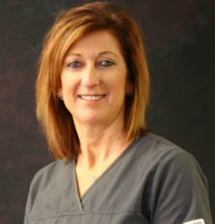
Guardian welcomes Jennifer Wildeman, RN, BSN as our new skilled services Administrator/D.O.N.

Jennifer Wildeman, RN, BSN comes to Guardian Home Health with fourteen years of health care experience to include hospital, long-term care & skilled rehab services. She grew up in the south-central Kansas town of Haviland but spent much of her younger years visiting family and friends at their Norton County farms in New Almelo and Lenora.

Jennifer began her college education at Johnson County Community College in Overland Park before relocating to Lenora in 1994. Prior to becoming a nurse, Jennifer also worked in Telecommunications at Rural Telephone/Nex-tech as a Project Coordinator in special billing, accounts receivables and as she often jokes, “other administrative duties as assigned.” After her stent in telecommunications, Jennifer moved her family to Wichita where she earned her first bachelor’s degree. Later, she moved back to Norton to be near family where she continued her education at Colby Community College and earned her LPN and RN nursing degrees. While working at the Norton County Hospital from 2004-2018, she continued her nursing education and graduated with a Bachelor of Nursing degree from Wichita State University.

During her time at Norton County Hospital, she held numerous positions to include Director of Nursing and Labor and Delivery Supervisor which have given her a wide variety of skills and expertise exposing her to the varying needs of patients in acute, skilled, newborn care and in the Emergency Department. Jennifer also carries certifications in Chemotherapy and Biotherapy. She has worked closely with the Colby Community College nursing program as a Clinical Instructor. Jennifer especially enjoyed working directly with and mentoring many nursing students and co-workers during her fourteen years with the hospital. Jennifer has a passion for nursing and goes above and beyond expectations to provide personalized care while taking a hands-on and personal approach with patients and family to educate and listen. She is eager to apply her experience to help Guardian accomplish our next set of goals in delivering skilled nursing and therapy-based services in the homes of our neighbors in northwest Kansas.

Jennifer and her husband Jamie Wildeman have been married for 15 years and have 3 children, Jacob 23, Hanna 20 and Rylan 13. Jennifer enjoys traveling to see friends and family, listening to music and attending concerts. Jennifer keeps busy attending as many of her husband's roping's and rodeo events as she can as well as traveling to cheer on her youngest son while he competes in sporting events. Tim Miller- CEO
Feel free to contact Jennifer at jennifer.wildeman@guardianks.com

About Guardian Home Health

Guardian strives to be the leader in home care and community-based services in Northwest Kansas. Guardian’s 2018 roadmap included expansion of services into Home Health, which many northwest Kansan’s so desperately need. The Mission is to strive to preserve our client’s independence and dignity, and instill hope while providing whole-person care. The Vision is to strive to provide emotional, physical support and care with daily activities whether the needs are ongoing or short-term due to an injury or illness. We place special emphasis on collaborating with our clients to create patient–centered plans of care they can understand. Our primary goal is to see that our clients remain in the comfort of their homes and avoid unnecessary hospitalizations for as long as possible. Our road map starts with personal Home Care support services followed by growth into a variety of skilled care services. Our highest priorities are: to deliver high quality services, to operate with integrity, to adapt to change, and to communicate with sincerity and compassion.

Learn more about how Guardian Home Health is changing the face of healthcare today. Visit www.guardianks.com, call 1-785-622-4254 or 1-888-560-5455 or follow us on https://www.facebook.com/guardiankansas

Share this news release

